**PLAYING WORDLE**

In order to play wordle follow the path.

Make a wordle pdf with the more than 13000 possible five letter words and a txt with a prompt run the create a database.py to create it:

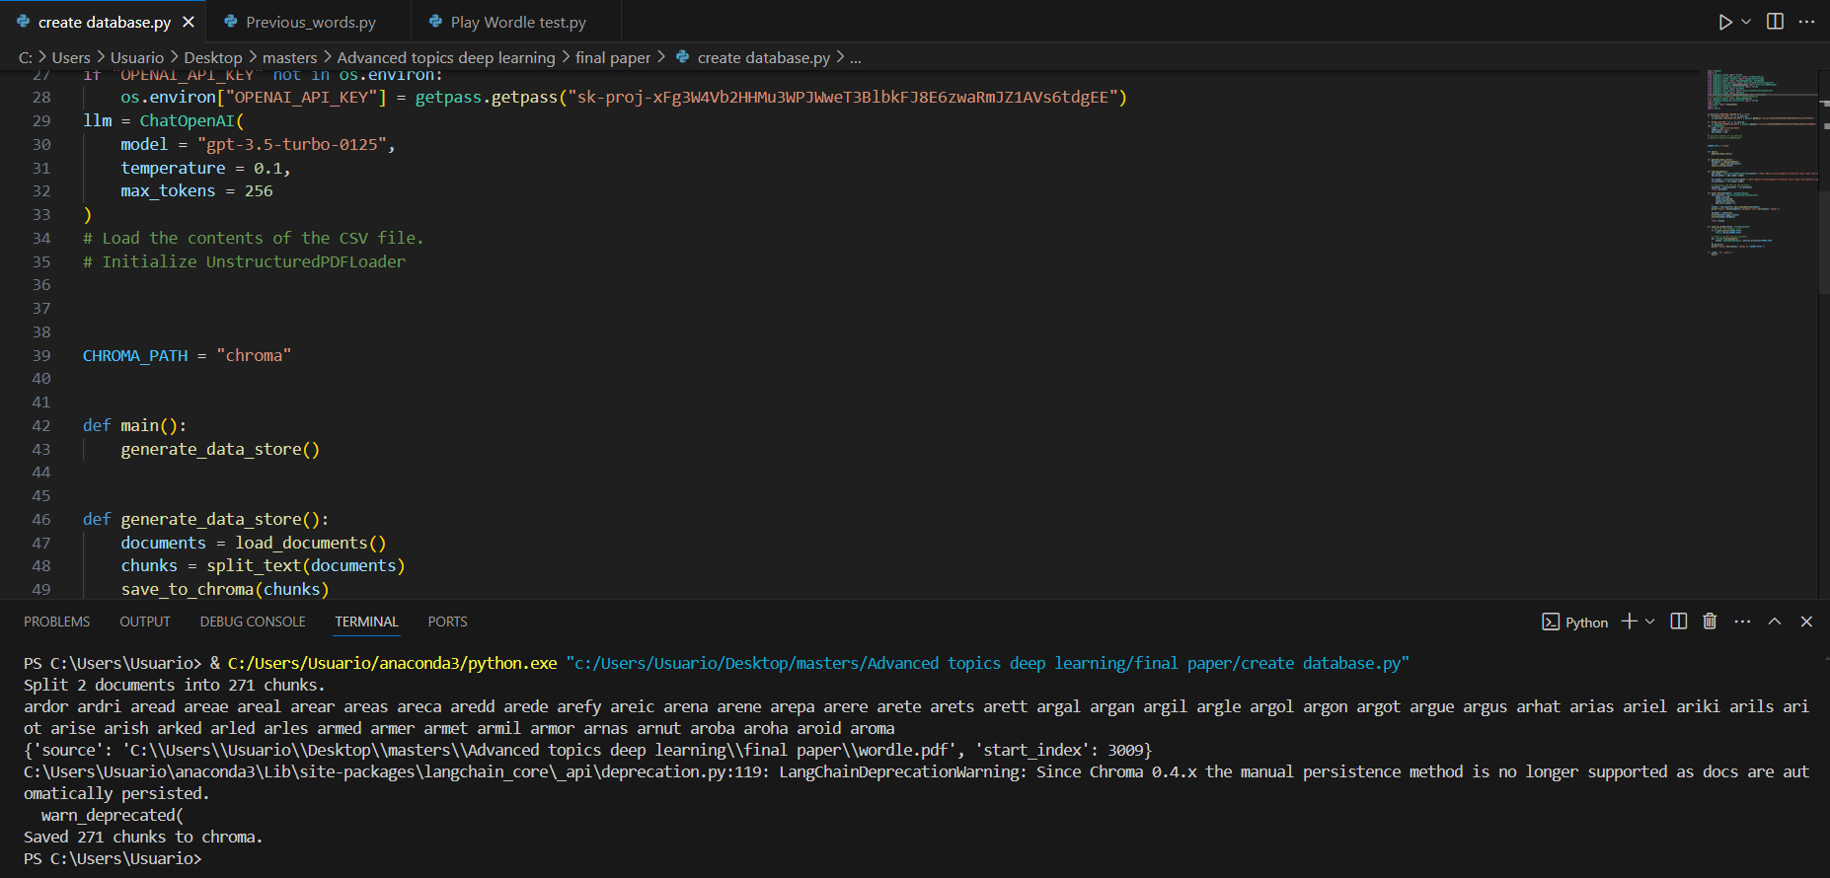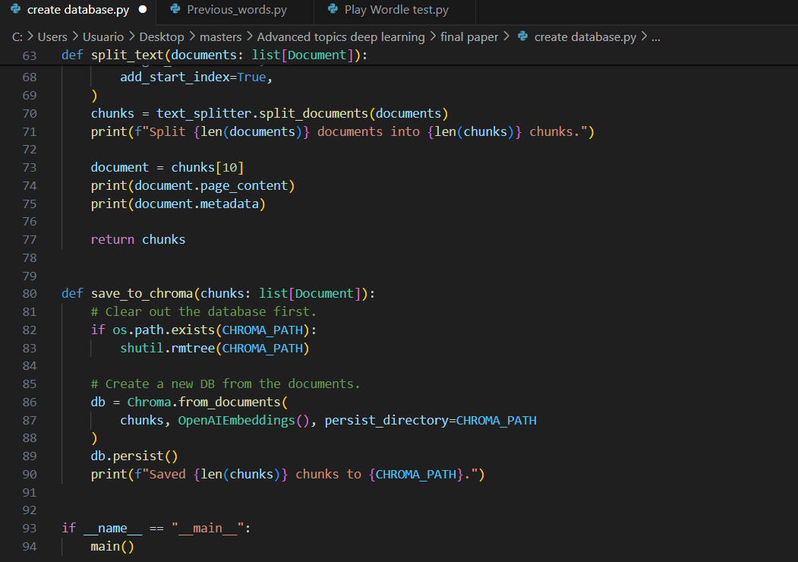

Create a txt with the previous words to be introduced as the words to be guessed by the llm:

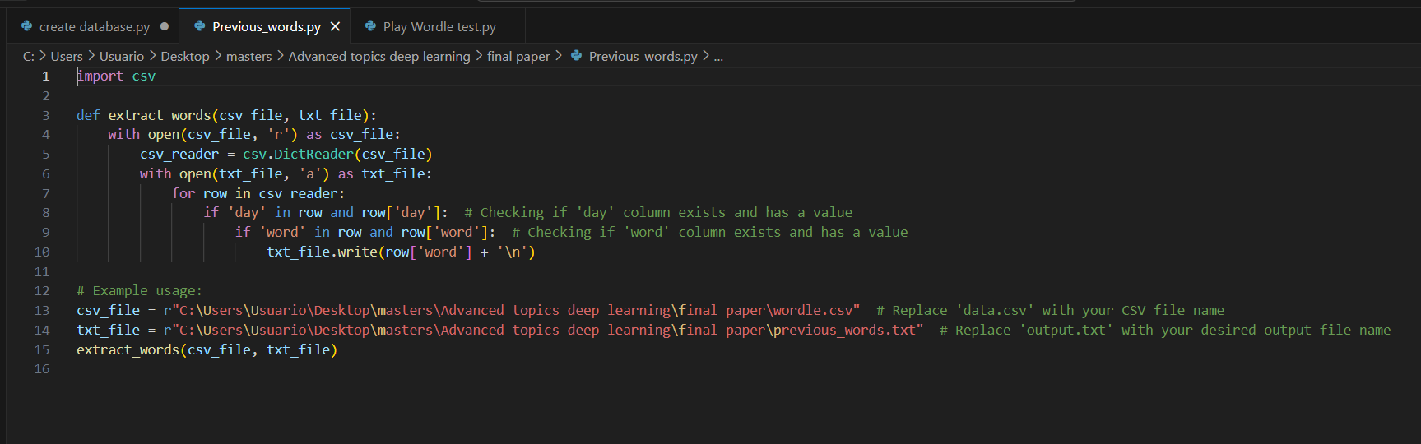

Run the play wordle.py:

